Launch one AWS ec2 and install Jenkins.

Steps:
1.login in AWS console
2.search for EC2
3.And click on Instances
4.Launch instance
5.Give a name or tag and click on amazon Linux AWS
6.select architecture 64-bit(*84)
7.select instance type t3 micro and create a new pair key
8.select no. of instances as 1
9.click on launch instance
10.instance launched successfully.
11.click on running instances and select we created or launched instance
12.click on connect and then select public IP
13.VM machine terminal is opened ,update the system
Sudo apt update -y
14.then install java for Jenkins
Sudo apt install openjdk-17-jdk—y
15.after check the java version
Java -version
16.install Jenkins
Sudo apt update -y
Sudo apt install Jenkins -y
17.start Jenkins service
Sudo systemctl enable Jenkins
Sudo systemctl start Jenkins
18.to access Jenkins check the Jenkins
Sudo systemctl status Jenkins
19.access Jenkins, open Jenkins in browser
http://(outcome public ip):8080
20.jenkins open
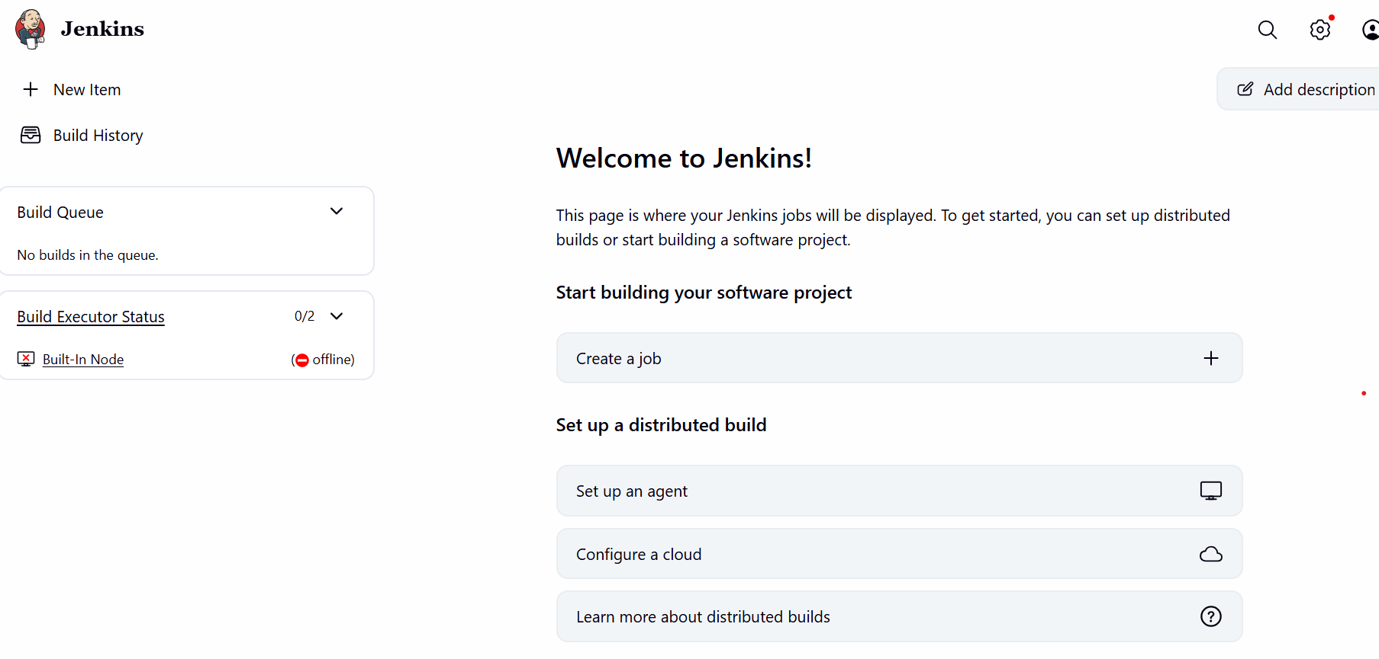

Setup Apache Tomcat on Ubuntu Virtual Machine
1.first we login into our AWS account and connect to the instance.
2.then select the ubuntu browser in that.
3.in order to install tomcat we need install java in ubuntu
Sudo apt install openjdk-17-jdk—y
4. after check the java version
Java -version
5.search for Apache tomcat file on browser
6.select the tomcat zip file
7.enter the command in ubuntu for get tomcat
Wget (zip file of tomcat we selected first)
8.ckeck it as command
Ls
9.unzip the file that command is
Unzip (file name apache-tomcat-10.1.50.zip)
10.check that command as unzip to zip
Cd apache-tomcat-10.1.50/cd.bin
Ls
11.then give the permission
Sudo chmod +x.sh
12.then start the tomcat
./startup.sh
13.one public ip comes after start tomcat
14. then copy that public ip and open link in public browser using localhost 8080
15.the outcome is open the our Apache tomcat .
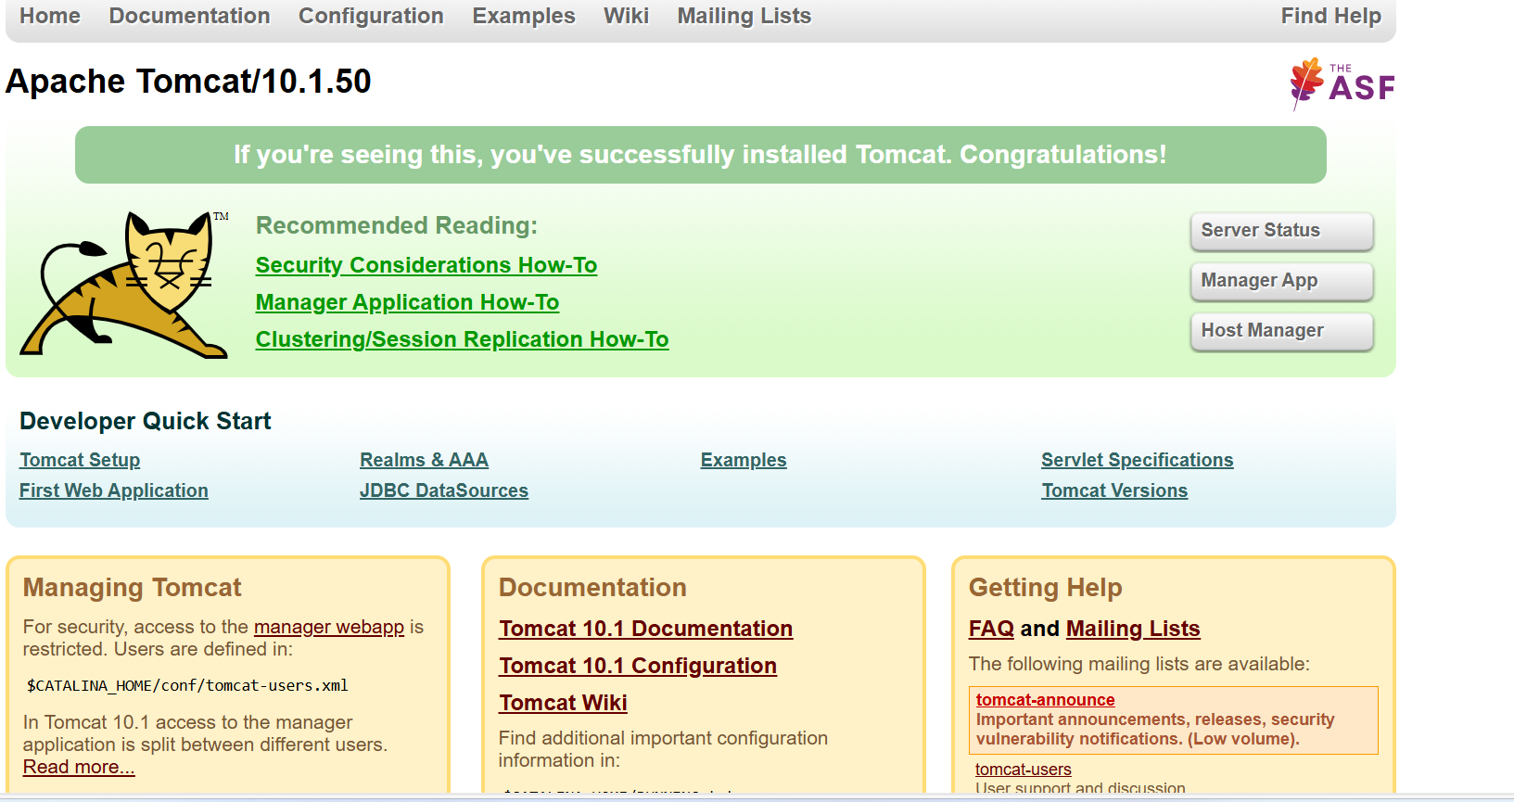
Setup Docker Desktop on your local windows
1.we want to install Docker Desktop in our computer then go to google browser
2.search for Docker Desktop
3. Docker Desktop’s official website opens
4.click on download Docker Desktop for windows
5.after download run the installer .exe file
6.select the ensure use WSL 2instead of hyper-v
7.click ok and wait for installation
8.after installation it asks for restart then allow to restart
9.after restarting the computer one desktop icon is there named Docker Desktop
10.click on it and Docker Desktop opens.
